|  |  |  |  |
| --- | --- | --- | --- |
| D:\Rinat\Rinat\доки\журнал\статьи\logo.jpg | FAST MOTIONS OF AN IRIDIUM DIHYDRIDE COMPLEX IN AQUEOUS MEDIUM REVEALED BY NMR RELAXOMETRY WITH HIGH-RESOLUTION | | |
| Cite this: *INEOS OPEN*, **2024**, X (X), XX–XX  *Received XX November 2024,*  *Accepted XX Month 2024*  http://ineosopen.org | | A. S. Kiryutin*, N. N. Fishman, and A. V. Yurkovskaya | |
| International Tomography Center SB RAS, Institutskaya 3A, Novosibirsk, 630090 (Russia) | |
| Abstract  We have investigated correlation times in the iridium dihydride catalytic complex [Ir(IMes)(Pyeq)2(Pyax)H2]Cl in water, where it remains stable for days. T1-relaxation times of individual protons were measured across magnetic fields using NMR with fast field cycling. Above 4 Tesla, T1 time increased, indicating a transition from fast (ωτc < 1) to slow motion (ωτc > 1) regime. Fitting the experimental data to a local magnetic field fluctuation model provided site specific rotational correlation times with an average of 280 ps for the whole molecule. | | |  |
| **Key words:** NMR, relaxation dispersion, correlation time, SABRE-complex. | | | |

Molecular mobility, namely the correlation times of rotational motions in solution, is a very useful characteristic of substances, which depends on the size of the molecule, temperature and solvent properties. This parameter often affects the spin relaxation time as it determines the mode of motion of the molecule slow or fast compared to the Larmor frequency.[1] Field-cycling Nuclear Magnetic Resonance (NMR) relaxometry is a versatile technique for studying molecular mobility and is suitable for a wide variety of systems: molecules in solutions, polymers, molecular and liquid crystals, as well as biomolecules.[2-3] Previously, our group determined the correlation times of the neutral iridium complex [Ir(IMes)(COD)Cl] in methanol.[4] Here, COD denotes cyclooctadiene and the carbene IMes structure is shown on Figure 1. This is the most popular pre-catalyst for the SABRE (Signal Amplification By Reversible Exchange) method, which has become very efficient and convenient way to enhance the NMR signal of some molecules capable of non-covalently reversibly binding ~~attaching~~ to the iridium hydride complex that constantly exchanges hydrogen atoms with dissolved para-hydrogen.[5-6]

In this work, we found that bubbling the pre-catalyst [Ir(IMes)(COD)Cl] with para-hydrogen in aqueous solution in the presence of 1% pyridine produced a stable positively charged iridium dihydride [Ir(IMes)(Pyeq)2(Pyax)H2]Cl with three pyridine ligands and the IMes carbene. Previously, the crystal structure of the complex was studied by X-ray for the crystals obtained from the organic solvents.[7] Also, the activation of the pre-catalyst in the presence of pyridine and nicotinamide was studied by indirect detection using para-hydrogen.[8] The SABRE experiments were performed in a strong magnetic field [9]; and NMR parameters of the complex in methanol-d4 were obtained.[10]

Here, we report the results of the proton T1-relaxation time measurements over the wide range of magnetic field from 0.5 T to 16.4 T using a home-build fast magnetic field cycling setup based on the high-resolution 700 MHz NMR spectrometer.[11]

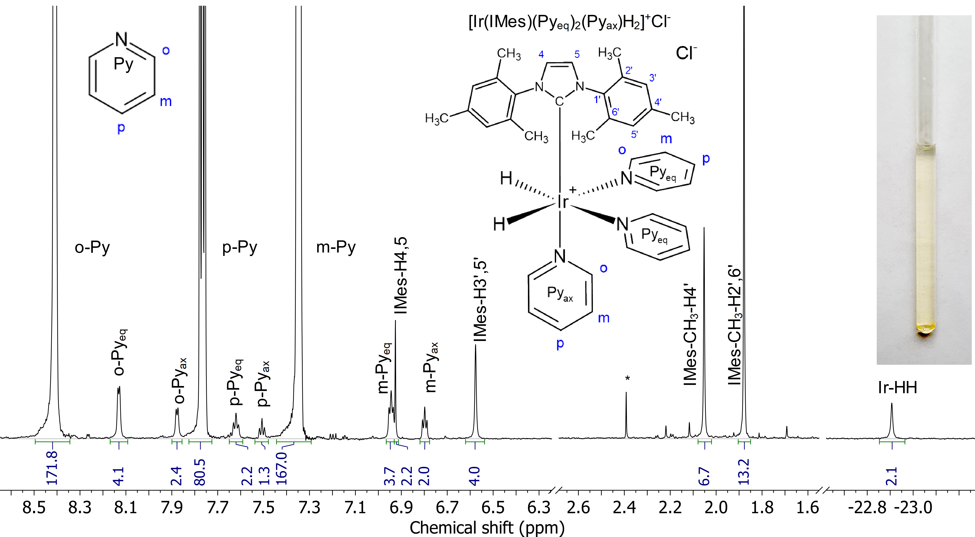

Figure 1. 700 MHz 1H{13C} NMR spectrum of [Ir(IMes)(Pyeq)2(Pyax)H2]Cl detected in aqueous solution at 25 oC. Molecular structure and atom numbering is shown on inset. Signal from impurity is marked by *. Relative integrals of signals are shown under the signals.

A sample containing 1.1 mg of pre-catalyst (synthesized according to the described in ref. [12] method), 6 µl pyridine, 30 µl D2O and 589 µl H2O was bubbled with hydrogen at 4 atm. pressure at 45 oC in an NMR tube for 15 minutes. The color change from yellow to colorless indicates the end of the hydrogenation reaction of cyclooctadiene and the formation of stable iridium dihydride stabilized by three pyridine molecules and carbene IMes. The 1H NMR spectrum of the resulting solution is shown in **Figure 1**, suppression during FID accumulation was applied to suppress 13C satellites.

Measurements of the relaxation time T1 were carried out by the recovery inversion method on a specially designed setup for rapid displacement of the sample along the vertical axis of the cryomagnet. The magnetic field for relaxation was determined by the position of the sample from the center of the cryomagnet bore. Experimental protocol: (1) Relaxation in a 16.4 T field for 15 s to create an initial Boltzmann polarization; (2) Application of a 180-degree hard pulse to invert the magnetization of all protons; (3) Moving the sample into the selected magnetic field (faster than 290 ms); (4) Holding the sample in the B0 field for a varying time from 0.01 to 10 s for relaxation; (5) Returning the sample to the detection field; (6) Delay 150 ms to calm down the vibration of the sample; (7) Recording the NMR spectrum using excitation sculpting[13] sequences to avoid excitation of the large H2O solvent signal, and using suppression of 13C interactions to get rid of satellite from pyridine signals.

Each relaxation kinetics contained 16 time points, was modeled by a decreasing exponent, and a set of T1 for each signal in the NMR spectra was obtained. The dependence of the relaxation time on the magnetic field was then plotted and fitted using equation (1), derived from the model of nuclear relaxation due to fluctuations of the local magnetic fields (**Figure 2**). As a result, the rotational correlation times, tc, for the protons of the complex were obtained and are summarized in Table 1.



Figure 2. Proton relaxation dispersion data. (symbols) T1-relaxation times of individual protons, (lines) fitting curve using function (1) and correlation times from Table 1.

, (1) where T1inf, A, tc – fitting parameters, gH – 1H gyromagnetic ratio

**Conclusions**

This work presents site-specific measurements of rotational correlation times for the [Ir(IMes)(Pyeq)2(Pyax)H2]Cl complex, revealing significantly shorter times than those previously reported for the precursor [Ir(IMes)(COD)Cl] in methanol[4], despite the larger size of iridium hydride and the higher viscosity of the solvent (water). Variations in correlation times among protons indicate that the molecule is not rigid. The marked independence of T1 relaxation times for equatorial pyridine (Pyeq) protons is attributed to chemical exchange with free pyridine in solution, with the exchange rate exceeding the nuclear relaxation rate, which is consistent with the data in methanol.[14] In contrast, for the protons of the axial pyridine the relaxation times T1 are much shorter and exhibit a strong magnetic field dependence similar to that of the protons of the tightly bound IMes ligand.

Table 1. Site specific rotational correlation times (tc) for the complex [Ir(IMes)(Pyeq)2(Pyax)H2]Cl in aqueous solution at 25 oC.

|  |  |  |  |  |  |  |  |
| --- | --- | --- | --- | --- | --- | --- | --- |
| Proton | m-Pyax | IMes-H4,5 | IMes-H3`,5` | IMes-CH3-H4` | IMes-CH3-H2`,6` | Ir-HH | Common |
| tc (ps) | 294±13 | 394±119 | 303±10 | 217±16 | 259±6 | 208±28 | 280±7 |

Acknowledgements

This work was supported by the Russian Science Foundation (project #23-73-10103).

Corresponding Author

* E-mail: kalex@tomo.nsc.ru. Tel: +7(383)330-3959

Electronic supplementary information

The ESI includes sample preparation details, HSQC spectra with signal assignments, a DOSY spectrum, temperature dependence, and a 15N SABRE spectrum for the studied complex.

References and notes

[1] J. Kowalewski, L. Mäler, in *Series in Chemical Physics, Vol. 2* (Eds.: H. J. Moore, N. D. Spencer), CRC Press Taylor & Francis Group Boca Raton, FL. , **2006**, p. 426 DOI: 10.1201/9781420012194

[2] C. Luchinat, G. Parigi, *J. Am. Chem. Soc.* **2007**, *129*, 1055-1064. DOI: 10.1021/ja0633417

[3] C. Charlier, S. N. Khan, T. Marquardsen, P. Pelupessy, V. Reiss, D. Sakellariou, G. Bodenhausen, F. Engelke, F. Ferrage, *J. Am. Chem. Soc.* **2013**, *135*, 18665-18672. DOI: 10.1021/ja409820g

[4] A. N. Pravdivtsev, A. V. Yurkovskaya, P. A. Petrov, K. L. Ivanov, *Z. Phys. Chem.* **2017**, *231*, 857-865. DOI: 10.1515/zpch-2016-0849

[5] R. W. Adams, J. A. Aguilar, K. D. Atkinson, M. J. Cowley, P. I. P. Elliott, S. B. Duckett, G. G. R. Green, I. G. Khazal, J. López-Serrano, D. C. Williamson, *Science* **2009**, *323*, 1708-1711. DOI: 10.1126/science.1168877

[6] D. A. Barskiy, S. Knecht, A. V. Yurkovskaya, K. L. Ivanov, *Prog. Nucl. Magn. Reson. Spectrosc.* **2019**, *114-115*, 33-70. DOI: 10.1016/j.pnmrs.2019.05.005

[7] M. J. Cowley, R. W. Adams, K. D. Atkinson, M. C. R. Cockett, S. B. Duckett, G. G. R. Green, J. A. B. Lohman, R. Kerssebaum, D. Kilgour, R. E. Mewis, *J. Am. Chem. Soc.* **2011**, *133*, 6134-6137. DOI: 10.1021/ja200299u

[8] S. Knecht, S. Hadjiali, D. A. Barskiy, A. Pines, G. Sauer, A. S. Kiryutin, K. L. Ivanov, A. V. Yurkovskaya, G. Buntkowsky, *J. Phys. Chem. Lett.* **2019**, *123*, 16288-16293. DOI: 10.1021/acs.jpcc.9b04179

[9] D. A. Barskiy, K. V. Kovtunov, I. V. Koptyug, P. He, K. A. Groome, Q. A. Best, F. Shi, B. M. Goodson, R. V. Shchepin, A. M. Coffey, K. W. Waddell, E. Y. Chekmenev, *J. Am. Chem. Soc.* **2014**, *136*, 3322-3325. DOI: 10.1021/Ja501052p

[10] A. S. Kiryutin, A. V. Yurkovskaya, H. Zimmermann, H.-M. Vieth, K. L. Ivanov, *Magn. Reson. Chem.* **2018**, *56*, 651-662. DOI: 10.1002/mrc.4694

[11] I. V. Zhukov, A. S. Kiryutin, A. V. Yurkovskaya, Y. A. Grishin, H.-M. Vieth, K. L. Ivanov, *Phys. Chem. Chem. Phys.* **2018**, *20*, 12396-12405. DOI: 10.1039/C7CP08529J

[12] I. Kownacki, M. Kubicki, K. Szubert, B. Marciniec, *J. Organomet. Chem.* **2008**, *693*, 321-328. DOI: 10.1016/j.jorganchem.2007.11.013

[13] T. L. Hwang, A. J. Shaka, *J Magn Reson Ser A* **1995**, *112*, 275-279. DOI: 10.1006/jmra.1995.1047

[14] O. G. Salnikov, C. D. Assaf, A. P. Yi, S. B. Duckett, E. Y. Chekmenev, J.-B. Hövener, I. V. Koptyug, A. N. Pravdivtsev, *Anal. Chem.* **2024**, *96*, 11790-11799. DOI: 10.1021/acs.analchem.4c01374